WINDOWS OPERATOR AND INSTALLATION GUIDE

HDB RV & OV Automation
Setup Guide
  - Node.js, Playwright, attachments, execution, status files, and manual stop procedures
REQUIRED VERSION BASELINE
Node.js 26.7.0 | npm 11.19.0
For users preparing and operating the authorized BanRad CRM to HDB RV/OV automation workflow.

1. Overview
This application automates HDB RV and OV verification workflows. After the user completes the HDB login and OTP steps and navigates to the required screen, the automation processes the relevant cases, uploads token-specific images, and records the result.
Technologies used: Node.js, npm, Playwright, and dotenv.

Supported flows
- HDB RV verification flow
- HDB OV verification flow

2. System Requirements
Component | Minimum | Recommended
Operating system | Windows 10 or Windows 11, 64-bit | Windows 11, 64-bit
Processor | 64-bit dual-core processor | Four-core processor or better
RAM | 8 GB | 16 GB
Free storage | 2 GB | 5 GB for browsers, images, reports, and logs
Display | 1366 x 768 | 1920 x 1080
Internet | Stable access to CRM, HDB, and npm | Reliable broadband connection
Desktop session | Visible Windows desktop session | Standard local desktop session

Required software versions
Software | Required version | Purpose
Node.js | 26.7.0 | Runs the automation worker and project scripts
npm | 11.19.0 | Installs packages and runs the project commands
Playwright | Installed by npm | Controls the visible Chromium browser used by the automation

VERSION BASELINE: The package engine permits Node.js 20 or newer, but this guide requires Node.js 26.7.0 and npm 11.19.0 to match the current tested environment.

3. Installation

Install Node.js
1. Download the Windows 64-bit installer for Node.js 26.7.0.
LINK: https://nodejs.org/en/download
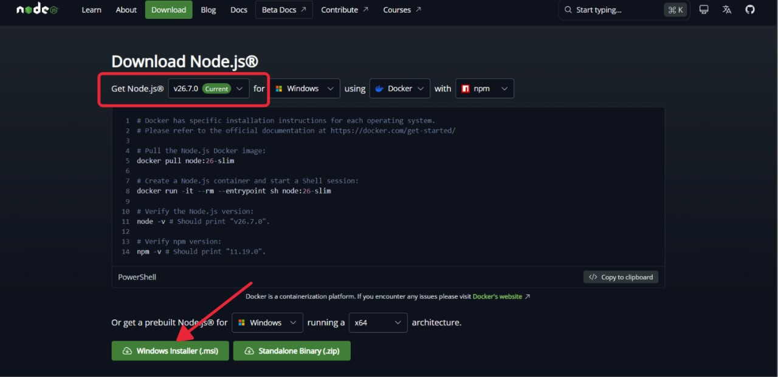
Make sure the required version is selected, then click 'Windows Installer' to download Node.js to your system.

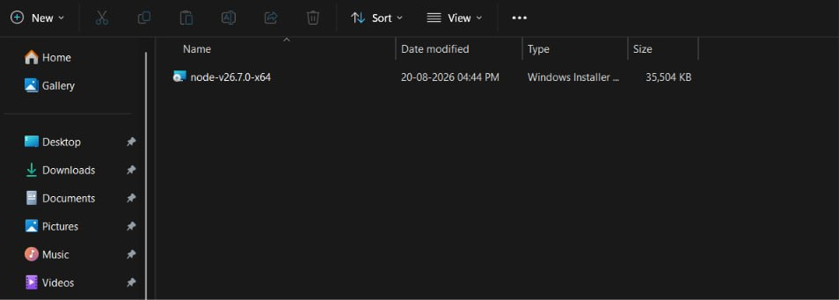

Double-click the downloaded file to install Node.js on your system.
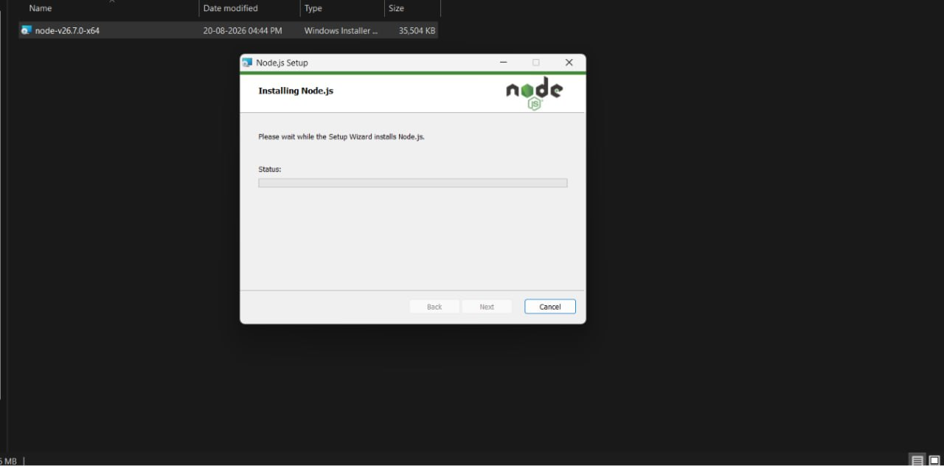

On the installation screen, finish the installation and close the installer.
2. Complete the installation, then close and reopen Command Prompt.
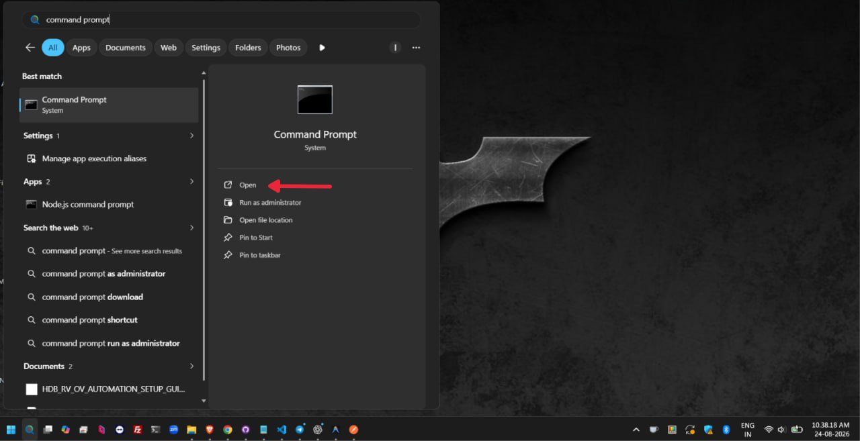
3. Verify the installed versions:
node -v
npm -v

Expected output:
v26.7.0
11.19.0

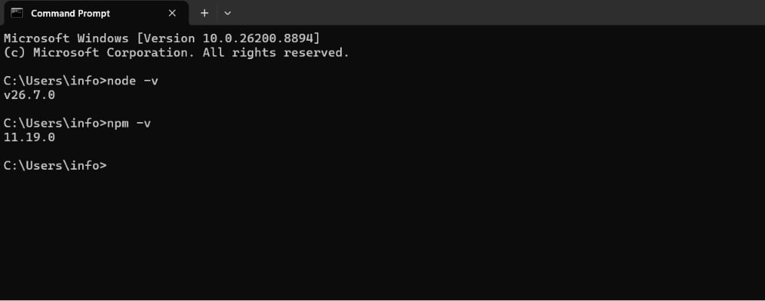

Install project packages
Open Command Prompt in the project folder containing package.json and package-lock.json.
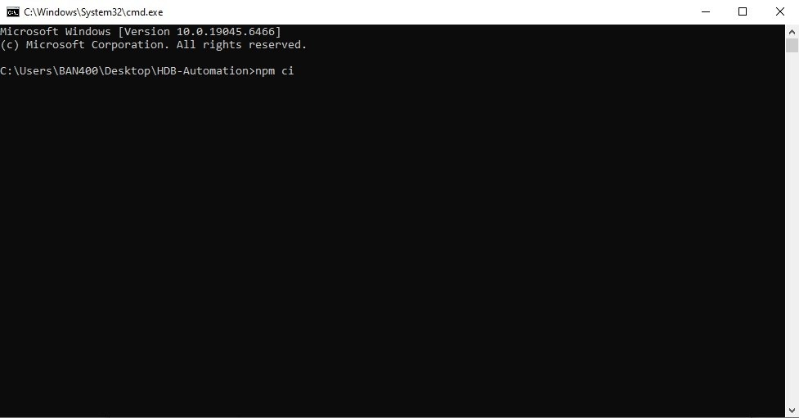

Then run:
npm ci
npx playwright install chromium
INSTALLATION RULE: Do not install Playwright globally. npm ci installs the project packages; the browser command installs the required Chromium binary.

4. Production Environment
Create or update .env.prod in the project root and add the authorized HDB portal URL:
HDB_PORTAL_URL=<ENTER_HDB_PORTAL_URL>

5. Attachment Images
Place the case images inside the attachments folder in the project root:
attachments/
Flow | Filename pattern | Example
RV | <TOKEN_ID>-rv.<ext>  <TOKEN_ID>-rv-1.<ext>  <TOKEN_ID>-rv-2.<ext> | 2735980-rv.jpg  2735980-rv-1.jpg  2735980-rv-2.jpg
OV | <TOKEN_ID>-ov.<ext>  <TOKEN_ID>-ov-1.<ext>  <TOKEN_ID>-ov-2.<ext> | 2735980-ov.jpg  2735980-ov-1.jpg  2735980-ov-2.jpg

Attachment rules
- The token ID in the filename must match the CRM/HDB case token.
- RV and OV are case-insensitive. Both -rv/-ov and -RV/-OV are accepted.
- Use one consistent naming style for all images belonging to the same token.
- Start with the base filename, then number additional images sequentially: -1, -2, -3, and so on.
- Keep the original image extension, such as .jpg, .jpeg, or .png.
- Do not add spaces to attachment filenames.

6. Run the Automation
- Run npm run start:hdb from the project folder (manual method)
Command | Purpose
npm run start:hdb | Validates .env.prod, copies it to .env, and starts the HDB worker in a visible browser.

npm run start:hdb

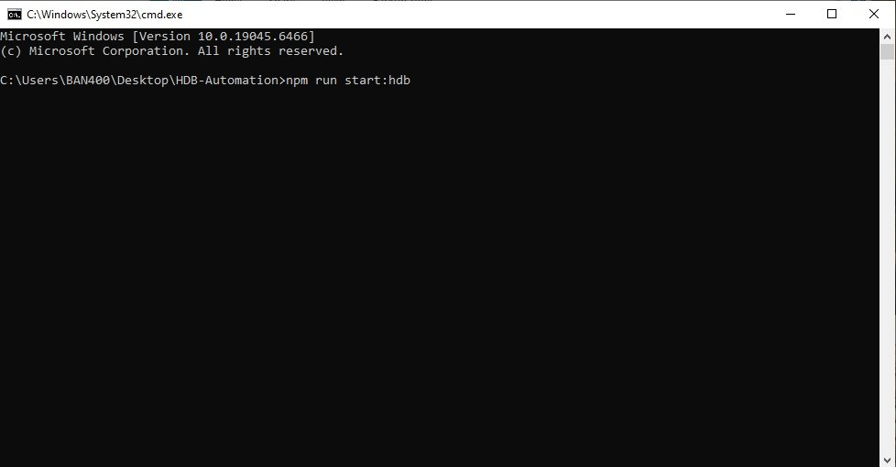

- Double-click to run the automation.
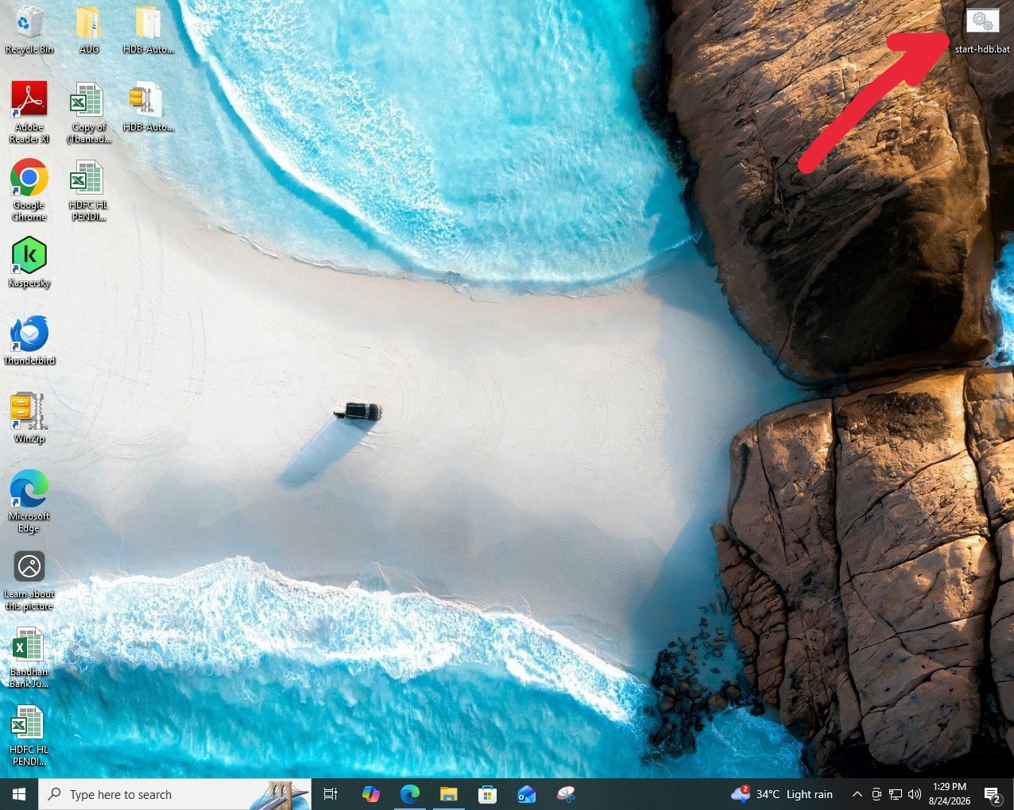

Manual login and OTP handoff
- Wait for the HDB portal to open in the visible browser.
- Complete the HDB login and OTP steps manually.
- Navigate to the screen immediately after the OTP screen.
- Keep the browser open on that screen. The automation takes control from this point and processes the cases.

7. Operator Workflow
This section describes what the operator does before and during each automation run. Follow these steps in order for every case.

STEP 1 — Login to the bank portal
Start the automation from the project folder. When the bank portal opens, log in using the authorized username and password, then complete the OTP manually.

STEP 2 — Open the case and download images
Go to the case list, open the required case, and download the images. Save them in the attachments folder using the filename rules described in Section 5.
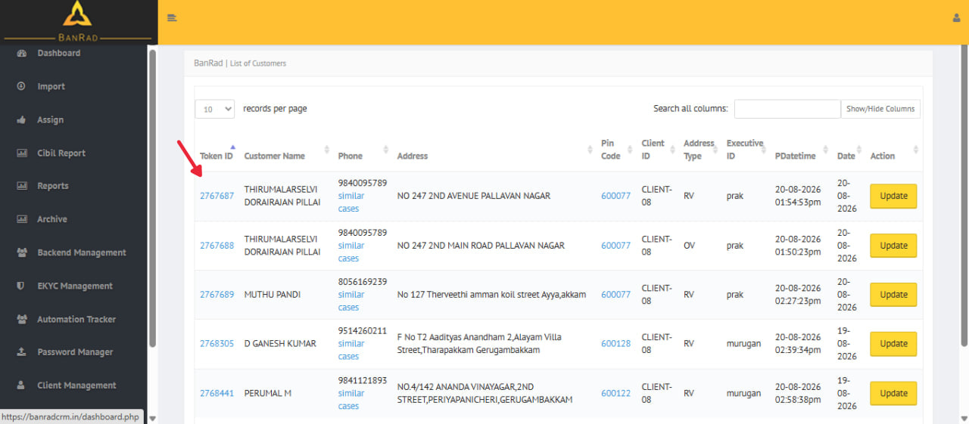
List of Customers — open the case using its Token ID
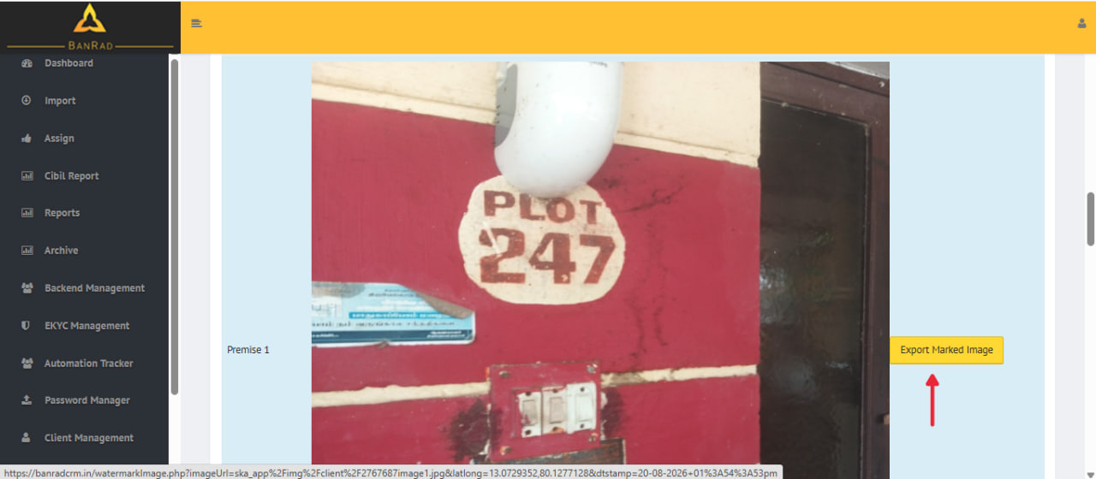
Case image view — download the image to the attachments folder
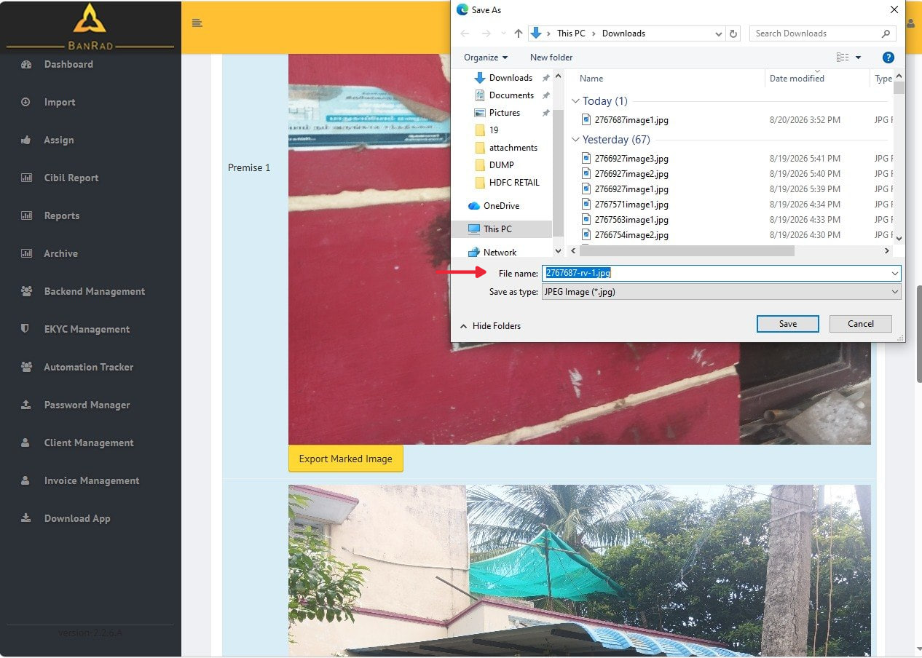
Ensure the files are saved in the “attachments” folder.

STEP 3 — Select the Final Recommendation
In the CRM, use the Final Recommendation dropdown. The available values are NIL, Referred, Positive, and Negative. Cases selected as NIL are not processed by the automation. Cases selected as Referred, Positive, or Negative are eligible for automation and will be processed when the automation starts.
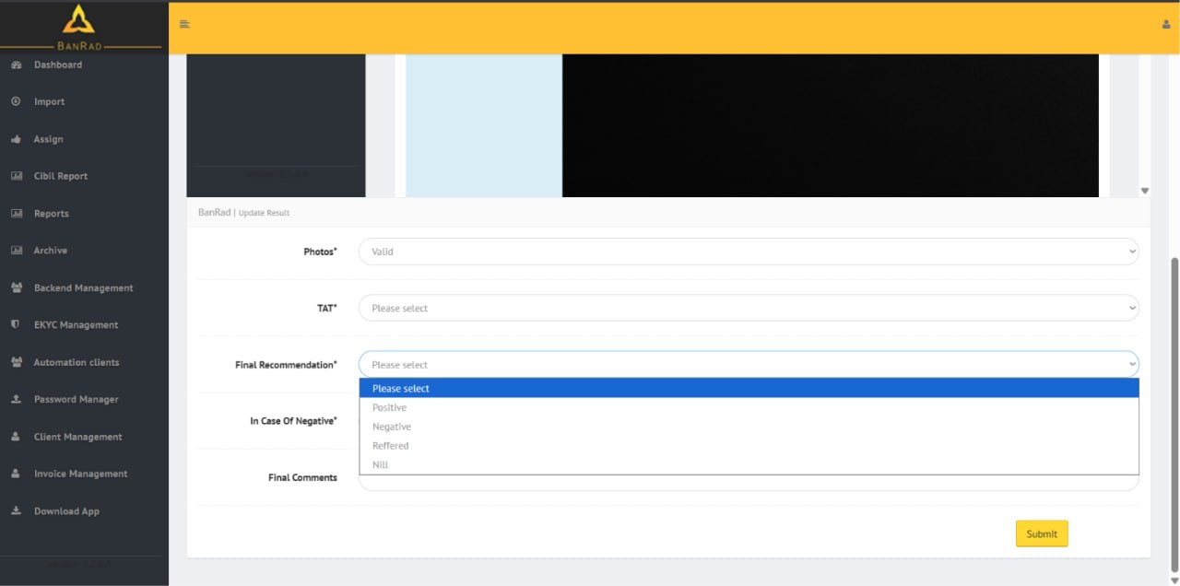
Update Result — select the Final Recommendation value

8. CSV Status Files and Failed Cases
RV and OV flow statuses are recorded in CSV files inside the outputs folder:
outputs/
1. Review the CSV files after the automation finishes or is stopped.
2. The files contain the recorded status of processed RV and OV cases.
KEEP CSV FILES CLOSED: Do not keep an RV or OV status CSV open while the automation is running. Excel or another spreadsheet application may lock or cache the file, preventing new updates from being written or displayed. Close the CSV before starting; after the run finishes, reopen it to view the latest records.

Failed cases
Failed automation cases are listed in the Failed Cases card in the BanRad CRM. Review that card for failed tokens, correct the attachment, data, or portal issue, and follow the application's retry procedure.
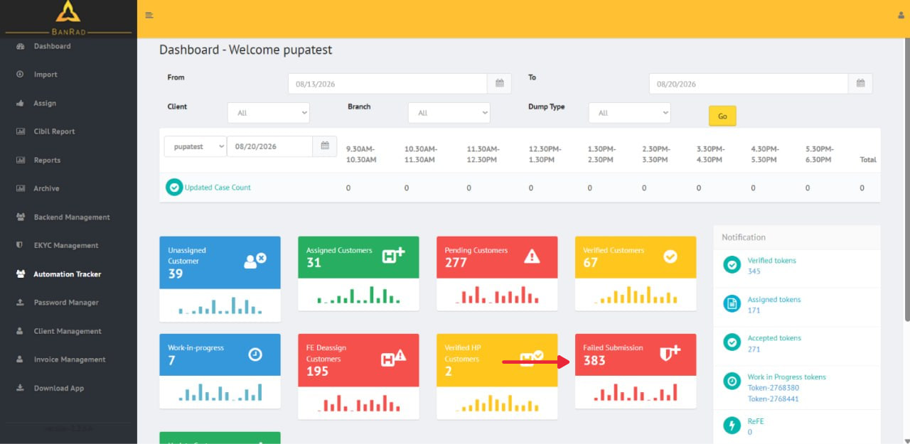

9. Stop the Automation Manually

Preferred method
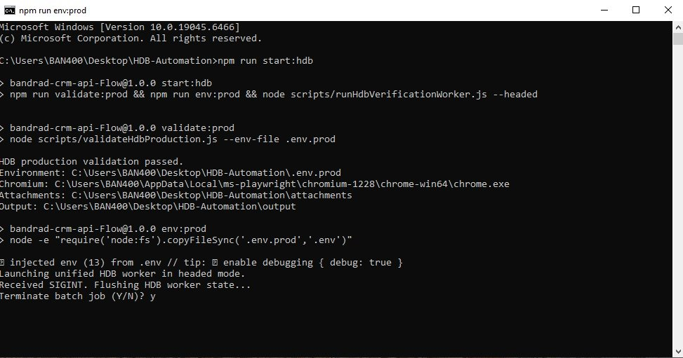
1. Select the Command Prompt window where the automation is running.
2. Press Ctrl + C.
3. If Windows asks, “Terminate batch job (Y/N)?”, enter Y and press Enter.
4. Wait until the normal command prompt returns.
5. Close the Playwright browser window only after the terminal process has stopped.
6. Open the CSV status files only after the process has fully exited.

If Ctrl + C does not work
1. Close the terminal window.

INTERRUPTED CASE: Stopping during an active case may leave that case incomplete. After stopping, review the RV/OV CSV files, check the Failed Cases card in BanRad CRM, and confirm the current token's status before restarting.

10. Important Keys and Operating Rules
Keep these rules in mind for every automation run.
- Do not switch or close browser tabs. Once the automation takes control, keep the automation tab active. Do not switch to another tab and do not close the tab.
- Do not close Command Prompt. The terminal is the running automation process. Closing it unexpectedly can interrupt the current case.
- Do not manually click in the automation browser. Only complete human-required steps such as login, OTP, or CAPTCHA when the Automation Tracker indicates intervention is required.
- Keep CSV status files closed during the run. Open the CSV files only after the automation has fully stopped or completed.
- Keep the internet connection stable. A network interruption can cause the portal session, uploads, or case processing to fail.
- Keep the computer awake and powered. Avoid sleep, shutdown, restart, or forced sign-out while the automation is running.
- Check attachments before starting. Confirm the correct token ID, RV/OV suffix, image sequence, and file extension before the automation begins.
- Respond to human-intervention prompts promptly. When the tracker turns red for login, OTP, or CAPTCHA, complete that step in the browser and then leave the automation to continue.
- After a manual stop, verify before restarting. Check the tracker, CSV status, and Failed Cases card so the same token is not incorrectly processed twice.

